**DAILY ONLINE ACTIVITIES SUMMARY**

|  |  |  |  |  |  |
| --- | --- | --- | --- | --- | --- |
| **Date:** | | **07/06/2020** | | | |
| **Name of the Faculty** | | **Shilpa** | | | |
| **No. of Students Allotted for monitoring** | | | | **19** | |
| **Progress** | | | | **Good** | |
| **Whether collected report from all the allotted students** | | | | **13 submitted.** | |
| **Online Test Summary** | | | | | |
| **Subject** |  | | | | |
| **Semester** |  | | | **Duration** |  |
| **No. of students Taken** | | |  | **Passing %** |  |
| **Certification Course Summary** | | | | | |
| **Course** | | 1. **Webinar on Deep Learning in Python** | | | |
| **Certificate Provider** | | 1. **Pantech e-learning** | | **Duration** | **1 Hour each** |
| **Coding Challenges** | | | | | |
| **Problem Statement: - Write a C++ Program to swap two numbers using friend as a bridge concept.** | | | | | |
| **Status: - 52** | | | | | |
| **Uploaded the report in Github** | | | | **YES** | |
| **If yes Repository name** | | | | <https://github.com/orgs/alvas-education-foundation/teams/2nd-year> | |
| **Uploaded the report in slack** | | | | **YES** | |

**Coding Challenge**

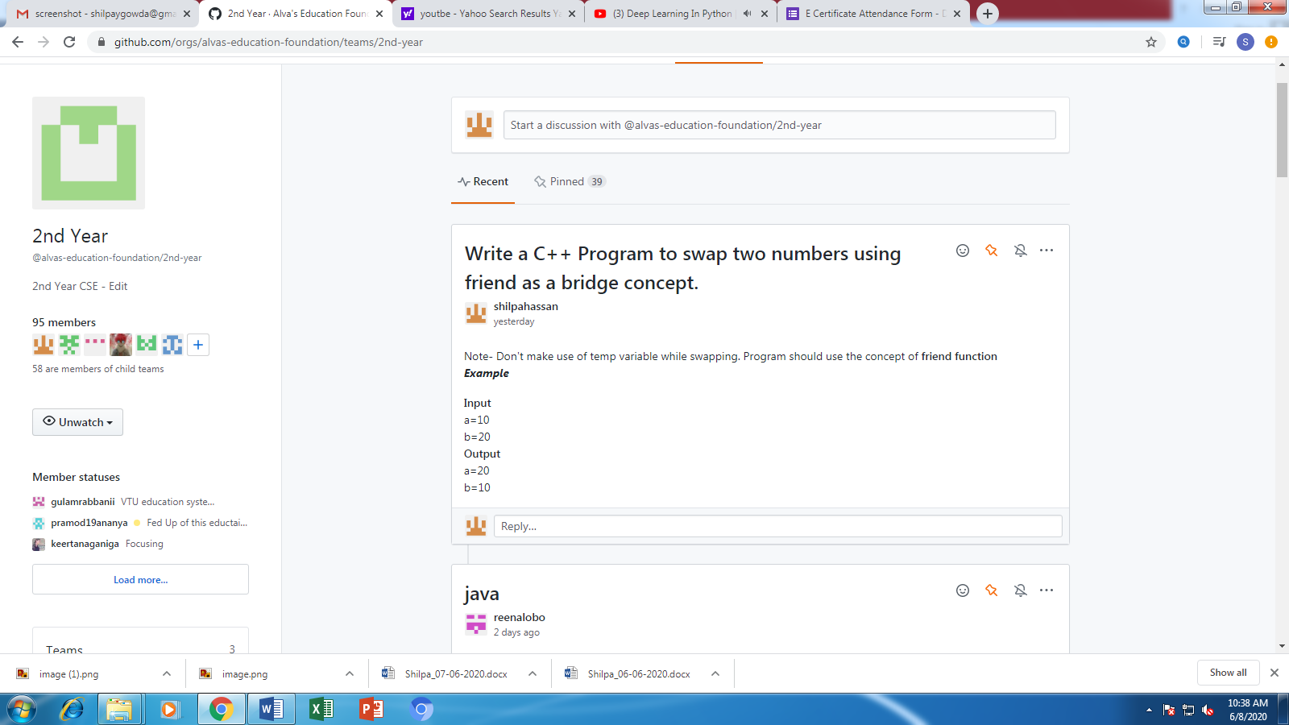

**Certification/webinar Course Summary**

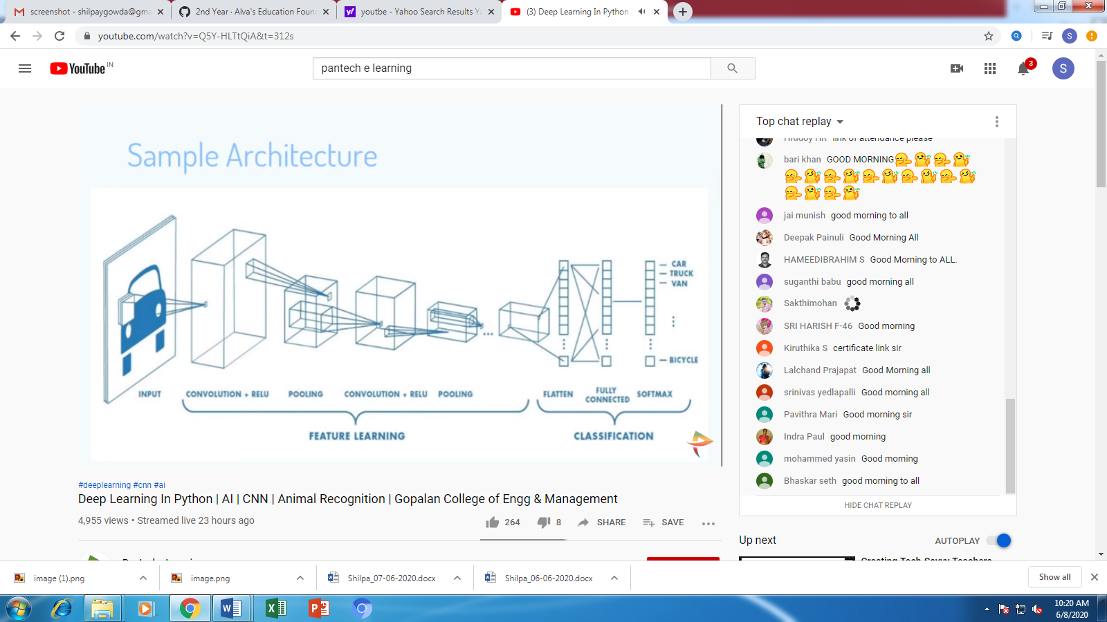

**Students Report:**

